**ST PAULS’ UNIVERSITY.**

**LIMURU CAMPUS.**

**NAME: OWEN NJOROGE M.**

**ADM NO: BOBITLMR154219.**

**UNIT NAME: SOFTWARE ENGINEERING II.**

**UNIT CODE: BCS 3106.**

**DATE DUE: 10TH AUGUST 2020.**

**Content Inventory.**

* Location (URL).
* Text: html, xml.
* File type.
* Application: pdf, doc, xls.
* Web files: jss, CSS.
* Images: jpeg, tif, png.
* Media: swf, mp3, mp4.
* Path.
* Size.
* Level.

**Architecture at an abstract level.**

Design translator

Design analyzer

Report generator

Python editor

Code generators

UML editors

Project repository.

Java editor

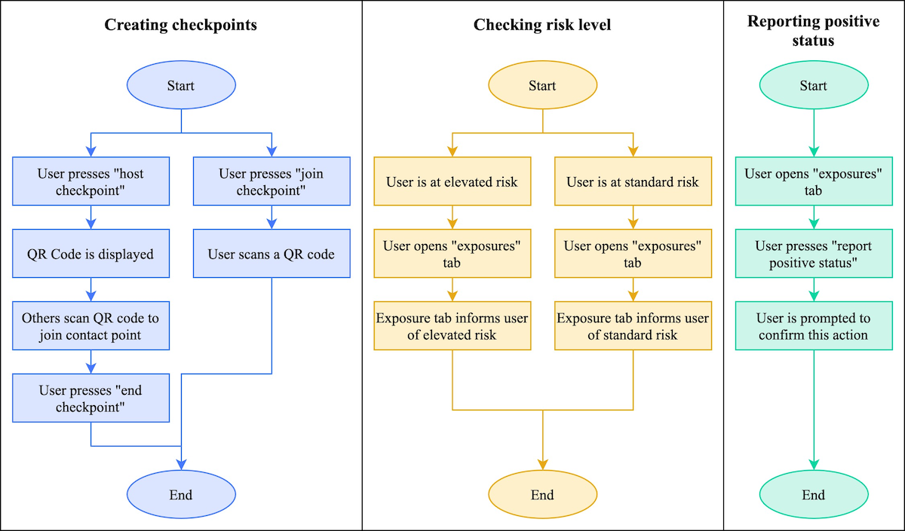

**Test plan.**

**Test Plan Identifier:**

* Provide a unique identifier for the document. (Adhere to the Configuration Management System if you have one.)

**Introduction:**

* Provide an overview of the test plan.
* Specify the goals/objectives.
* Specify any constraints.

**References**:

* List the related documents, with links to them if available, including the following:
  + Project Plan
  + Configuration Management Plan

**Test Items:**

* List the test items (software/products) and their versions.

**Features to be Tested:**

* List the features of the software/product to be tested.
* Provide references to the Requirements and/or Design specifications of the features to be tested

**Features Not to Be Tested**:

* List the features of the software/product which will not be tested.
* Specify the reasons these features won’t be tested.

**Approach**:

* Mention the overall approach to testing.
* Specify the testing levels [if it’s a Master Test Plan], the testing types, and the testing methods [Manual/Automated; White Box/Black Box/Gray Box]

**Item Pass/Fail Criteria:**

* Specify the criteria that will be used to determine whether each test item (software/product) has passed or failed testing.

**Suspension Criteria and Resumption Requirements:**

* Specify criteria to be used to suspend the testing activity.
* Specify testing activities which must be redone when testing is resumed.

**Test Deliverables**:

* List test deliverables, and links to them if available, including the following:
  + Test Plan (this document itself)
  + Test Cases
  + Test Scripts
  + Defect/Enhancement Logs
  + Test Reports

**Test Environment:**

* Specify the properties of test environment: hardware, software, network etc.
* List any testing or related tools.

**Estimate:**

* Provide a summary of test estimates (cost or effort) and/or provide a link to the detailed estimation.

**Schedule:**

* Provide a summary of the schedule, specifying key test milestones, and/or provide a link to the detailed schedule.

**Staffing and Training Needs:**

* Specify staffing needs by role and required skills.
* Identify training that is necessary to provide those skills, if not already acquired.

**Responsibilities:**

* List the responsibilities of each team/role/individual.

**Risks:**

* List the risks that have been identified.
* Specify the mitigation plan and the contingency plan for each risk.

**Assumptions and Dependencies:**

* List the assumptions that have been made during the preparation of this plan.
* List the dependencies.

**Approvals:**

* Specify the names and roles of all persons who must approve the plan.
* Provide space for signatures and dates. (If the document is to be printed.)

**Test case.**

|  |  |
| --- | --- |
| **Test Suite ID** | TS001 |
| **Test Case ID** | TC001 |
| **Test Case Summary** | To verify that clicking the Generate Coin button generates coins. |
| **Related Requirement** | RS001 |
| **Prerequisites** | 1. User is authorized. 2. Coin balance is available. |
| **Test Procedure** | 1. Select the coin denomination in the Denomination field. 2. Enter the number of coins in the Quantity field. 3. Click Generate Coin. |
| **Test Data** | 1. Denominations: 0.05, 0.10, 0.25, 0.50, 1, 2, 5 2. Quantities: 0, 1, 5, 10, 20 |
| **Expected Result** | 1. Coin of the specified denomination should be produced if the specified Quantity is valid (1, 5) 2. A message ‘Please enter a valid quantity between 1 and 10’ should be displayed if the specified quantity is invalid. |
| **Actual Result** | 1. If the specified quantity is valid, the result is as expected. 2. If the specified quantity is invalid, nothing happens; the expected message is not displayed |
| **Status** | Fail |
| **Remarks** | This is a sample test case. |
| **Created By** | John Doe |
| **Date of Creation** | 01/14/2020 |
| **Executed By** | Jane Roe |
| **Date of Execution** | 02/16/2020 |
| **Test Environment** | * OS: Windows Y * Browser: Chrome N |